Last week’s lecture started discussion of logic and in designated “~” as the symbol for negation. I knew that in various programming languages “!” is used to refer to the opposite of a value, as in: if ! (foo.class = bar) then quz. So my mind wondered about different math symbols and I remembered an old question I had been meaning to look up. Namely, the difference between two stroke equal signs and three stork equal sign. A few google searches provided the answer. The difference between the two symbols only becomes evident when a variable is present in the statements involving the equal sign. The three stroke equal sign is used when the statement is valid regardless of what we replace the variable with. And the two stroke equal sign is designated for situations where only a limited set of values can replace the variable.

(x+2)^2≡x^2+4x+4 is valid for any replacement of x whereas (x+2)^2=16 is only valid if x is 2 or -6. So, the three stroke equal sign designates an identity, more on that later.

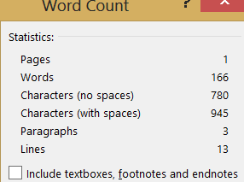

**10/26/2013**